University Hospitals Bristol and Weston NHS Foundation Trust

Report on Nurse (RN’s), Midwifery (RM’s) and Allied Health Professionals (AHP’s) Staffing Levels UHBW (October 2023 – March 2024).

Context

Following publication of the Francis Report 2013 and the subsequent “Hard Truths” (2014) document, NHS England and the Care Quality Commission issued joint guidance to Trusts on the delivery of the commitments associated with publishing staffing data on nursing, midwifery and care staff levels. These include:

- Report and publish a monthly return to NHS England indicating planned and actual nurse staffing by ward. This is published on the NHS Choices website.

- Publish information with the planned and actual registered and unregistered nurse staffing for each shift.

- Provide a 6-month report on nurse staffing to the Board of Directors.

The RCN workforce Standards (2021) report have been reviewed and compliance continues to improve with actions in place to support best practice.

Contents

- Nursing Report
- Midwifery Report
- Allied Health Professionals Report
- Summary
- Recommendations.

There are 3 specific strategic nurse, midwifery and AHP staffing risks graded as high risk held on the corporate risk register as below. The risks have all been reduced due to the improved vacancy and turnover positions sustained over the past 6 months.

For all staff groups

Risk Number | Details | Risk Level | Score
737 | Risk that the Trust is unable to recruit sufficient numbers of substantive staff – all staff groups. | Strategic Risk Register | 8  (↓12)
2694 | Risk that the Trust is unable to retain members of the substantive workforce. | Strategic Risk Register | 8  (↓12)
5477 | Risk that nurse staffing levels will not be met. | Strategic Risk Register | 9  (↓12)

For Midwives

Risk 988: - This risk has been reduced as the number of transfers out or inability to admit neonates has decreased due to improved vacancy levels, however some NICU cots remain closed due to the inability to safely staff cots all the time.

Risk Number | Details |  | Risk Level | Score
33 | Risk that inadequate nursing levels in line with BAPM standards 2011 will affect neonatal outcomes |  | Departmental | 15
988 | Risk that neonates are transferred out to alternative NICU units due to lack of cot capacity |  | Departmental | 9
3623 | Risk that extreme pre-term babies will have a sub-optimal outcome due to inability to deliver in a tertiary centre |  | Departmental | 8

For AHPs

Risk Number | Details | Risk Level | Score
737 | Risk that the Trust is unable to recruit sufficient numbers of substantive staff | Strategic Risk Register | 8  (↓12)
2694 | Risk that Trust is unable to retain members of the substantive workforce | Strategic Risk Register | 8  (↓12)

- The report highlights the work being undertaken to mitigate the above risks.

1. Nursing Report

Trust Metrics overview

The previous 6 months Trust level staffing metrics are contained within Table 1, the Divisional summary tables can be found in the appendices.

Key points to note: -

- The adult fill rates have now consistently been above 95%. Bristol Royal Hospital for Children (BRHC) fill rates have however remained slightly below this level at 93%. This does show an improvement over the last 6 months. The night HCSW fill rate remains above 100%, this is to ensure vulnerable patients are kept safe with enhanced care observation.

- All in-patient area fill rates are based on the funded beds and do not include the additional boarding beds within a ward and escalation beds, when in use these beds are an additional workload for staff.

- The vacancy level for band 5 staff has now reduced to 4.8% (90.1 WTE) in March 2024 with approximately 150 new starters awaiting OSCE and PIN’s.

- The Registered Nurse Turnover rate continues a downward trend (from 13.4% down to 11.3%) due to the successful recruitment of Internationally Educated Nurses (IEN’s), Newly Qualified Nurses (NQN’s) and the impact of the Trust wide focus on retention initiatives.

- Care hours per patient day (CHPPD) is a measure of actual nursing resource deployment and the registered nurse (RN) CHPPD and total CHPPD are included in the metric tables. Trust wide RN CHPPD has remained within the range 6.5 – 6.8. UHBW benchmarks well against peers in the model hospital dashboard and is in the highest national quartile for CHPPD.

- The level of red flag reporting remains low as more roster gaps are covered due to reduced vacancy levels or from temporary staffing assignments. The low staffing incident reports over the past 6 months is also on a downward trend compared to the period March to September 2023.

- NICE Midwifery red flags are now included below and will be reported each month through the Safe Staffing Report as per the CQC Improvement recommendations.

Table 1 - Trust Metrics
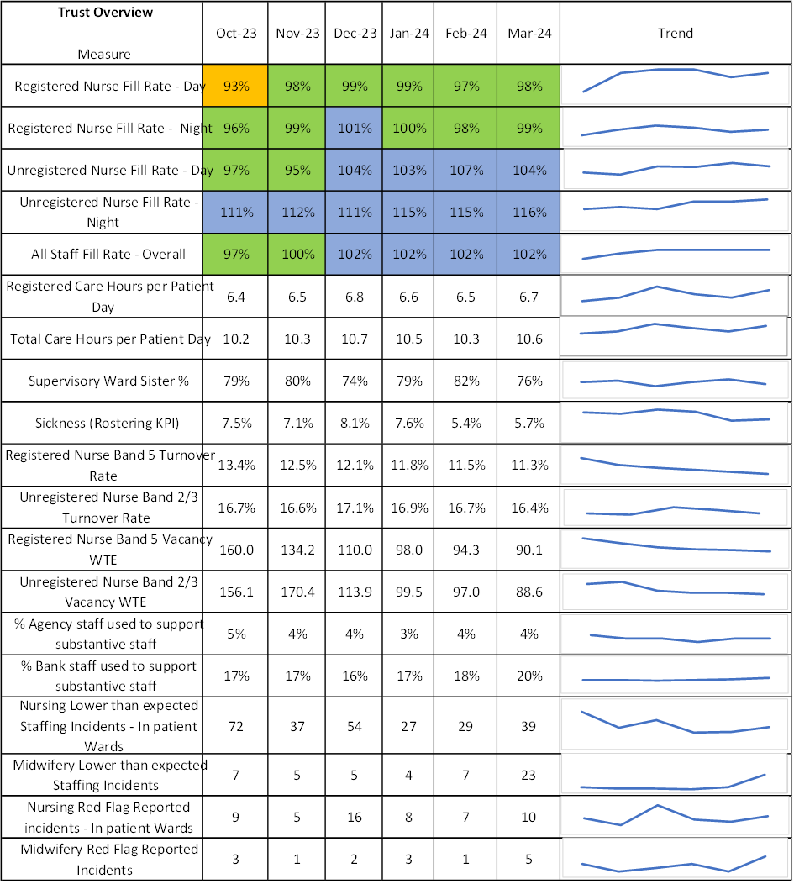
*Midwifery lower than expected staffing incidents and red flags increase in March 2024 in line with change in NICE Midwifery red flag reporting

Safer Nursing Care Tool 2023

- The Trust has completed 4 cycles of the Safer Nursing Care Tool (SNCT) assessments using the available Adult, Children and Young Person and Emergency Department tools. After the annual staffing reviews and with professional judgement analysis, the results of these audits have supported changes in nursing establishments over the last 12 months.

- A revised adult tool was published in October 2023, this new version has been expanded to include the care for one-to-one Enhanced Care Requirements (ECO) assignments and for patients requiring a two-to-one or more staffing level to ensure both patients and staff are kept safe.

- A detailed training programme based on the national NHS England requirements is being delivered to all key adult-based staff in preparation for the SNCT audits during July 2024, November 2024 and February 2025. The data obtained from November onwards will support the Trust staffing reviews.

- The Children’s and Emergency Department tools are unchanged and will continue to be undertaken in July and February each year as standard.

Update to the Key areas requiring a change to the establishments from the November 2023 report:

- The Medicine Division reviewed their establishments based on the July 2023 SNCT audits and following a detailed professional judgement process a small reduction of Band 2 and Band 5s in some wards was undertaken. This enabled movement of funding within the Division to improve patient experience for care of the elderly and patients requiring enhanced care.

- The overnight staffing for D603 (Adult Oncology) has now been fully funded.

- The BRHC Intensive Care Department (PICU) nursing establishment is being increased with funding agreed to meet the Paediatric Critical Care Society (PCCS) standards and equates to an additional 7.74 WTE nurses plus 4 WTE Clinical Skills facilitators to staff 18 beds all year round. This includes a 26% headroom factor (allowing for 15% annual leave, 5% essential training, 5% sickness and 1% special leave) as recommended by the PCCS standards.

- Following a full review against the Association for Perioperative Practice (AfPP) guidelines the funding for the planned increase of 12.66 WTE has been agreed for the BRHC’s theatre department.

- The Funding has now been agreed for a fully staffed 5-day per week Trust wide Palliative care team, with recruitment for the nursing roles underway.

The Emergency Department Safer Nursing Care Tool (SNCT)

- The BRHC ED increase in funding for nurse staffing has been agreed, this will increase the substantive WTE by 20 WTE, this will continue to be monitored through the ongoing SNCT audits.
- The BRI ED reviewed the skill mix and have piloted a senior nurse to minimize crowding and maintain safety across the department. This has been a successful cost neutral change with a notable improvement in patient experience and flow out of the ED.

- Weston ED identified staffing increases were not funded through the operational planning review.

  - These posts remain a cost pressure for Weston: 5.2 WTE RN and 5.2 WTE HCSW for the ED Observation Unit, 5.2 WTE RN for a Rapid Assessment and Treatment Team and 1 x HCSW to support ED flow across the busiest period 12.00 – 00.00.

- Additional funding was obtained for the expansion of the vascular access team to cover Weston Hospital providing a fully supported service across both sites.

- D601 Teenage and Young Adult Cancer Unit. An additional 5.6 WTE HCSW required to support changes in acuity and dependency, following a Quality and Equality Impact Assessment, the mitigation is in place but is currently unfunded.

The Advanced Practitioner Role in UHBW.

- UHBW is recognised as a leading employer and an innovator of advanced practitioner (AP) services. Since 2021, it has grown from approximately 40 trainees and 19 qualified APs to 54 trainees and 39 qualified AP across 12 specialties. UHBW has shown a clear intention in the investment of the AP role and the surrounding governance and clinical supervision for these roles.

- The past 3 years has seen UHBW establish a trust wide approach to the training and introduction of AP services. Across BNSSG, UHBW has the greatest diversity of multiprofessional trainees, has established Divisional AP Leads with a clear vision for the next 5 years, outlined in both UHBW 3-year AP Strategy and UHBW 5-year Workforce Plan.

- A clear clinical career pathway has now been defined along the continuum of the scope of practice, from novice to enhanced and advanced practitioner and ultimately consultant practitioner. To this effect, UHBW is standardising nomenclature of role descriptor to provide clarity and professional identity to members of the multi-disciplinary team, the patients and carers who use our services and members of the public.

- Midwifery Report

Introduction

This section of the report details the specific requirements and actions taken by Midwifery Services to ensure that all mothers and babies are given quality care in a safe and secure environment.

The Trust continues to review its services against the landmark publications of the Ockendon Reports in December 2020 and March 2022 to assure the Trust that the Midwifery services are responding appropriately to the recommendations outlined in these two reports. A full Birthrate plus workforce assessment was undertaken in June 2022 with the next formal review planned for 2025/2026.

Between October 2023 and March 2024 staffing in both Maternity and Neonatal Intensive Care Unit (NICU) has been challenging due to the level of sickness and the number of vacancies within the teams, but the flexibility of the workforce and joint working between midwifery and the neonatal unit has maintained safe staffing in these areas.

In midwifery the hospital on-call midwife and the on-call community midwives have been used in periods of high acuity and/or activity to support staffing shortfall with the midwifery on-call manager available for support. There are twice daily flow meetings held between maternity, gynaecology, and neonatology each day with the ‘flow midwife monitoring activity and the movement of staff during the week. The data recorded in the Birthrate Plus tool informs the flow midwife of hotspots on the day.

Birth rate Plus acuity tool. Table 2

October 2023  Completed scheduled data entry 53% | November 2023  Completed scheduled data entry 60.1% | December 2023  Completed scheduled data entry 51.8%
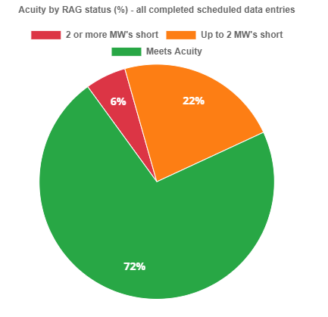 | 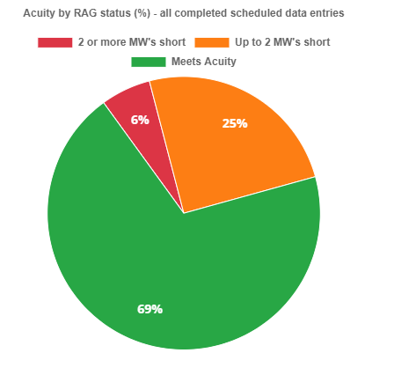 | 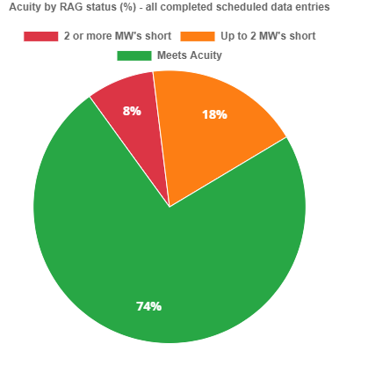
January 2024  Completed scheduled data entry 55.4% | February 2024  Completed scheduled data entry 45.2% | March 2024  Completed scheduled data entry 60.1%
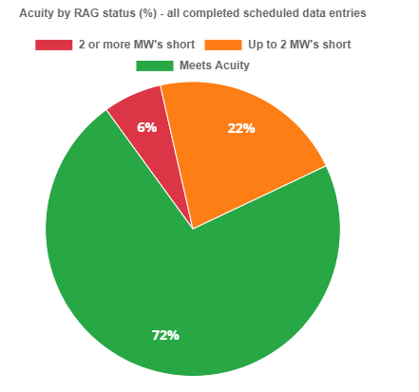 | 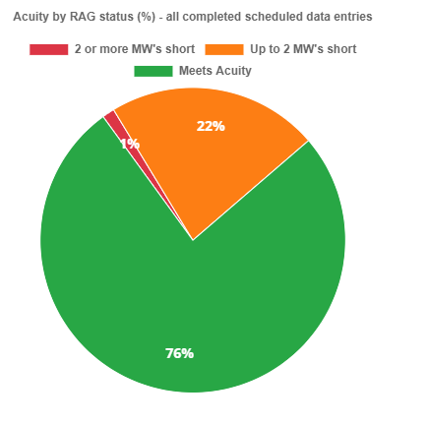 | 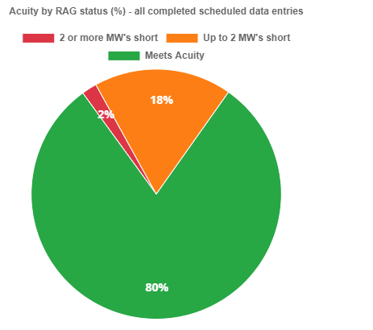
The Birth rate Plus acuity tool is used on the delivery suite to help manage the midwifery staffing and trigger escalation. The data compliance for October 23 - March 24 shows an improvement on the preceding 6 months from 20 - 40% completed compliance to 50-60% completed compliance. This increased compliance is expected to continue to improve as the tool is embedded in the Central Delivery Suite. The percentage of times the service was green has also improved over the six-month period.

Recruitment

There has been a successful level of recruitment into Midwifery services over the past 6 months with 10.26 WTE vacancies recruited into with staff commencing in April. Midwifery continues to hold regular recruitment open days with the aim to recruit to turn over.

The department have received on going funding from the Local Maternity and Neonatal System (LMNS) for the recruitment and retention midwife who works alongside the Divisional recruitment and retention lead. This role actively ensures exit interviews are encouraged and leads on the wellbeing initiatives for staff.

Within the neonatal service there were 3.5 WTE Band 5 and 2.5 WTE Band 6 vacancies at the end of March 2024. Safe staffing has been managed by the closure of cots and the use of bank incentives however by September 2024 the NICU expects to be recruited to turnover.

The Division welcomed the extension of the funding for the bereavement team by the LMNS providing essential support for both maternity and neonatal patients/carers.

Staffing and CQC.

The Maternity service was inspected in December 2023 by the CQC and was rated as ‘Good’ overall, with one requirement and one recommendation made for Safe Staffing.

CQC Requirement | Regulation | Findings | Action
That 'red flag' midwifery staffing incidents are monitored effectively, including delays to induction of labour, in line with national guidance. | Regulation 18 (1) | The service did not effectively monitor maternity ‘red flag’ staffing incidents in line with NICE guideline 4 ‘Safe midwifery staffing for maternity settings'... Managers did not monitor and compare maternity red flag incidents in the six nursing and midwifery staffing reports to trust board in line with national guidelines | 1) Ensure all managers monitor and compare maternity red flags.  2) Report on Midwifery red flags in the Monthly safe staffing report highlighting any action.

Red flags including delayed inductions are monitored through the PQSM (Perinatal Quality and Safety Maternity Matrix) and daily flow meetings. Red flags as per NICE guidelines were added in July 2023 on the Datix system. Red flags and themes of staffing issues are monitored monthly through the individual area governance groups and at the hospital Women's Governance Group and escalated as necessary to the Divisional Quality Assurance Committee.

Staffing is monitored daily at flow meetings and staff are moved to manage any risks, including use of the on-call midwife. As a result of the CQC visit all staff were reminded to record any staffing related safety incidents or where mitigations have been required when reporting unsafe staffing incidents on Datix including the use of NICE red flags.

As a result of the above actions, there has been an increase in red flag reporting over the previous months. See below Table 3
Table 3 – Midwifery red flag reporting

2023
2024
Grand Total

Sep
Oct
Dec
Jan
Feb
Mar
Central Delivery Suite - Ward 77(StMH)
Midwifery Red Flag 1:1 Care
1
1
1
1
1
5
Midwifery Red Flags: Delay of 30 minutes presentation to triage
1
1
2
Midwifery Red Flags: Delayed Time Critical Activity
1
1
1
1
4
Midwifery Led Unit (StMH)
Midwifery Red Flag 1:1 Care

Ward 73 (Maternity) StMH
Midwifery Red Flags: Delayed Time Critical Activity
1
1
2
4
Ward 76 - Transitional Care (StMH)
Midwifery Red Flags: Delayed Time Critical Activity
1
1
Grand Total
2
3
2
3
1
5
16

The recommendation from the CQC for staffing was to ensure there are enough midwifery staff to provide a full range of maternity choices including use of the midwifery-led unit (MLU). The CQC noted that "Midwifery staffing levels impacted on the availability of the midwifery led unit’.

The midwifery led unit was staffed from the 11 midwives assigned to Central Delivery Suite (CDS) with two midwives covering the midwifery led unit if there was a woman wanting to use the facility. Staffing gaps due to sickness and vacancy has impacted on CDS’ ability to support women to give birth on the MLU within a specific shift. However, this has been sustained whenever possible by moving staff from other areas and by using the on-call midwife overnight or at weekends without compromising the overall safety of the service.

Following recent recruitment in March 2024 the CDS is now able to allocate and name two midwifery staff members per shift to support any woman fitting the criteria and opting for MLU birth. There has been a 75 % increase in births in the MLU following this change.

Continuity of carer teams

The service has maintained the 4 continuity of carer midwifery teams, mainly present in areas of high deprivation and ethnic diverse population. In addition, funding has been received from the LMNS for enhanced maternity support workers to reach out to vulnerable women and facilitate earlier engagement into the Maternity service. 33.45% of women giving birth at UHBW In March 2024 were receiving care from a continuity midwifery team.

- Allied Health Professionals (AHP’s) report

The Trust employs nine professional groups as allied health professionals (AHP) and range across all divisions in the Trust with: -

- 867 (730.79 WTE) AHPs registered with the Health and Care Professionals Council (Bands 5-8D)

- 125 (100.65 WTE) support workers and assistants (Bands 2-4)
Apart from national guidance for stroke and critical care (adults and paediatrics), there is no tool for deciding safe staffing levels for AHPs within inpatient settings, with staffing levels generally determined by demand-capacity and patient/non-patient related activity data.

The current AHP staffing turnover has reduced and is at 12.9%. Vacancies within the specialties and professional groups vary with problem areas in diagnostic radiography and occupational therapy reflecting national areas of difficulty in recruitment.

Recruitment and Retention:

We are continuing to implement plans set out in the Director of AHPs recruitment and retention plan (presented to the People Committee in September 2023). As part of the progress in that plan:

- A second joint recruitment exercise across UHBW, North Bristol Trust (NBT) and Sirona for band 5 occupational therapists and physiotherapists resulted in offering posts for nine occupational therapists and eight physiotherapists. Plans to over recruit to diagnostic radiographers and adult therapies have been submitted to help ease the need for multiple recruitment rounds.

- After a successful consultation exercise in Weston diagnostic radiography the CT scan facility has now moved to a 24/7 service (from an on-call service) in line with ambitions set out in the Healthy Weston 2 plan. The Trust have also re-started hosting pre-registration students in the Weston site as the recently recruited cohort of international radiographers have settled in and are working to their competencies.

- The Trust has been successful in securing funding from NHS England Southwest to provide enhanced support to the internationally educated AHPs in partnership with NBT and Sirona.

- UHBW is also increasing the offer of pre-registration apprenticeships into the professions of Occupational Therapy, Physiotherapy, Dietetics, Diagnostic and Therapeutic Radiography.

- Ongoing work to recruit to Advanced Practitioner roles continues with the successful appointments of a Consultant Practitioner in Adult Therapies (critical care) and Consultant Practitioner – radiotherapy (Prostate Cancer) this year.

- An integrated (nursing, midwifery and AHP) preceptorship programme for newly registered practitioners commenced this year and all disciplines are reviewing the competencies for support workers (bands 2-4) to align them to the national framework.

- Exploratory work has commenced to move AHP staff onto the e-Job planning process to support improved role clarity and transparency across all the AHP disciplines.

- Assurance statement and summary.

The Trust continues to closely monitor staffing levels and comply with the recommendations outlined in the Developing Workforce Safeguards guidance (2018). The SNCT cycles completed over the past 12 months support the nursing establishment setting process using a recognised evidence-based approach. Noting the staffing information detailed in this report, alongside the robust escalation and mitigation of short- and long-term staffing shortfalls.
The conclusion is that professional judgement indicates that the Trust has in place sufficient processes and oversight of its staffing arrangements to ensure safe staffing is prioritised as part of its routine activities, whilst also supporting development for both the registered and non-registered Nursing and Midwifery workforce and the AHP staff.

The last 6 months have seen significant improvement with recruitment overall as more Internationally educated nurses fully joined the nursing workforce. Many adult areas are now recruited to turnover.

Safe staffing has been supported with nurse bank incentives which have provided an increase in the bank fill rate and enabled a sustained reduction of off framework agency use. The significant improvement in the vacancies and effects of the retention programmes has ensured that the Trust is well prepared for any risks which may occur through the agency cap rate reduction.

Pressure on the front door service has continued over this 6-month period requiring the regular opening of extra capacity areas and supporting the ED queues in the adult ED departments. Increasingly this is now being staffed by substantive or bank staff instead of agency staff.

The turnover position in the BRHC has shown an improving trend, from 16.9% in October 2023 to 13.5% in March 2024. The overall vacancy level within BRHC has fluctuated over the months however there is a strong recruitment pipeline to support the Division over the next 6 months.

- Recommendations for Trust Board

The Trust Board is offered assurance of detailed monthly monitoring and reporting to the Quality and Outcomes committee which provides fill rates by wards, red flag reporting and detailed analysis and review of all the safe staffing incidents reported, along with triangulation of impact on patient quality outcomes and staff experience.

The Trust Board is asked to note the following:

- Continue the approach outlined using the Safer Nursing Care Tool (SNCT) assessments to underpin nursing establishment on all in-patient wards, both adults and children and ED’s acknowledging this is a process that will evolve over time after each assessment. Recommended uplifts of staffing will also be subject to scrutiny and support via the annual operational planning round.

- Following the last Annual safe staffing review and operational planning the funded increases in staffing have been agreed in:

  - Bristol Royal Hospital for Children’s Emergency Department
  - BRHC Paediatric Intensive Care unit
  - BRHC theatres
  - Trust Wide Palliative Care services
  - D603 (Adult Oncology) Increase to night duty staffing.
  - Funding for the Vascular access nurse at Weston

- Note that the 5.6 WTE HCSW for D601 (Teenage and Young adults with Cancer unit) is in place but remains substantively unfunded.

- Note that the Weston ED continues to have staffing in post for the ED observation unit and the Rapid Assessment and Treatment service which is unfunded.

- Note the changes being made within the Division on Medicine based on the SNCT results and professional judgement that has enabled movement of funding within the Division to improve patient experience for care of the elderly and patients requiring enhanced care.

- Note the CQC Requirement for Maternity safe staffing and the actions in place to achieve this.

- Support the continued evaluation work required to review the budgetary impact of the increasing level of training required in specialist areas. National recommendations would suggest a 1% - 4% increase to support Critical Care, ED’s and Maternity areas where the level of specialist training is greater.

Report of the Mid Staffordshire NHS Foundation Trust Public Inquiry - GOV.UK (www.gov.uk)
NHS England » Guidance issued on Hard Truths commitments regarding the publishing of staffing data
Nursing Workforce Standards | Professional Development | Royal College of Nursing (rcn.org.uk)

